COMBO DEMONSTRATION REPORT – 1
Seed to Harvest
Details Of Farmer
Name of Farmers | SURESH SINGH
Mobile No. | 8210449385
Village Name | MADAN DERA (PURSOTIPUR)
Block & Tehsil | ITADHI
District & State | BUXAR

Field And Crop Detail
Total Acreage(acre) | 15 ACRE
Crops Grown | 15 ACRE
Field Location (Easy approach/road side) | ROAD SIDE
Selected - Crop & Variety | PADDY MTU-7029
Trial Plot Area (KATHA) | 36 KATHA (INCULDING T1+ T2+ T3)
Seed Rate (kg/acre) | 8 KG/ACRE
Sowing Date | 14.07.2025

Demo Product Name And Dose& Field day detail
Name of Product | SALTON
Application Dose (ml/acre) | 6 KG
Date/Time of Application | 14.07.2025
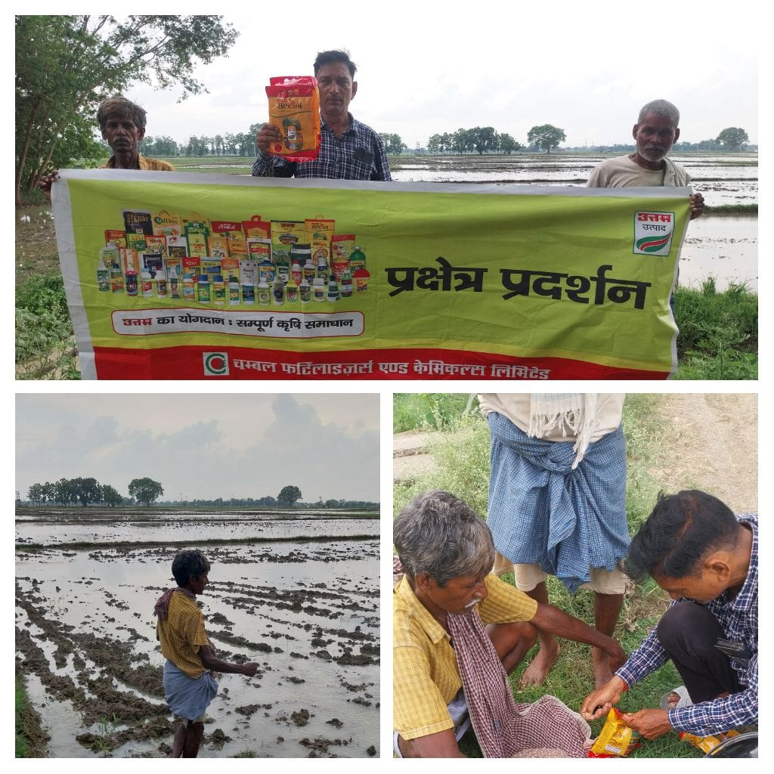
COMBO DEMONSTRATION REPORT – 2
Seed to Harvest
Details Of Farmer
Name of Farmers | BRAJESH YADAV
Mobile No. | 9955826896
Village Name | KHOCHARIHA
Block & Tehsil | RAJPUR
District & State | BUXAR

Field And Crop Detail
Total Acreage(acre) | 12 ACRE
Crops Grown | 12 ACRE
Field Location (Easy approach/road side) | ROAD SIDE
Selected - Crop & Variety | PADDY MTU-7029
Trial Plot Area (KATHA) | 33 KATHA (INCULDING T1+ T2+ T3)
Seed Rate (kg/acre) | 8 KG/ACRE
Sowing Date | 14.07.2025

Demo Product Name And Dose& Field day detail
Name of Product | SALTON
Application Dose (ml/acre) | 5.32 KG
Date/Time of Application | 14.07.2025

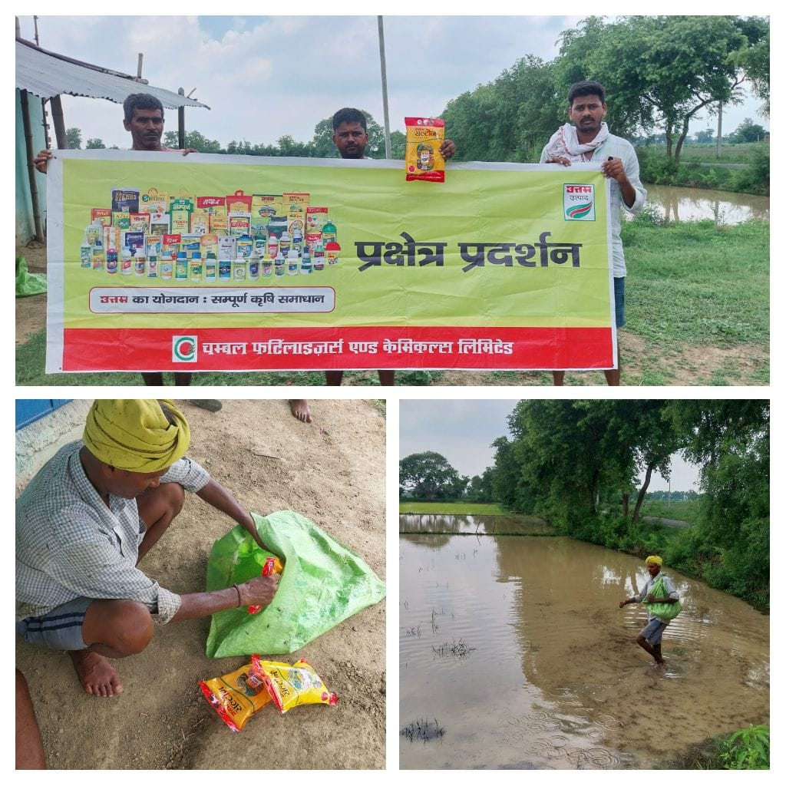

COMBO DEMONSTRATION REPORT – 3
Seed to Harvest
Details Of Farmer
Name of Farmers | ARUN SINGH
Mobile No. | 9973159121
Village Name | CHILAHAR
Block & Tehsil | ITADHI
District & State | BUXAR

Field And Crop Detail
Total Acreage(acre) | 8 ACRE
Crops Grown | 8 ACRE
Field Location (Easy approach/road side) | ROAD SIDE
Selected - Crop & Variety | PADDY MTU-7029
Trial Plot Area (KATHA) | 30 KATHA (INCULDING T1+ T2+ T3)
Seed Rate (kg/acre) | 8 KG/ACRE
Sowing Date | 15.07.2025

Demo Product Name And Dose& Field day detail
Name of Product | SALTON
Application Dose (ml/acre) | 5 KG
Date/Time of Application | 15.07.2025

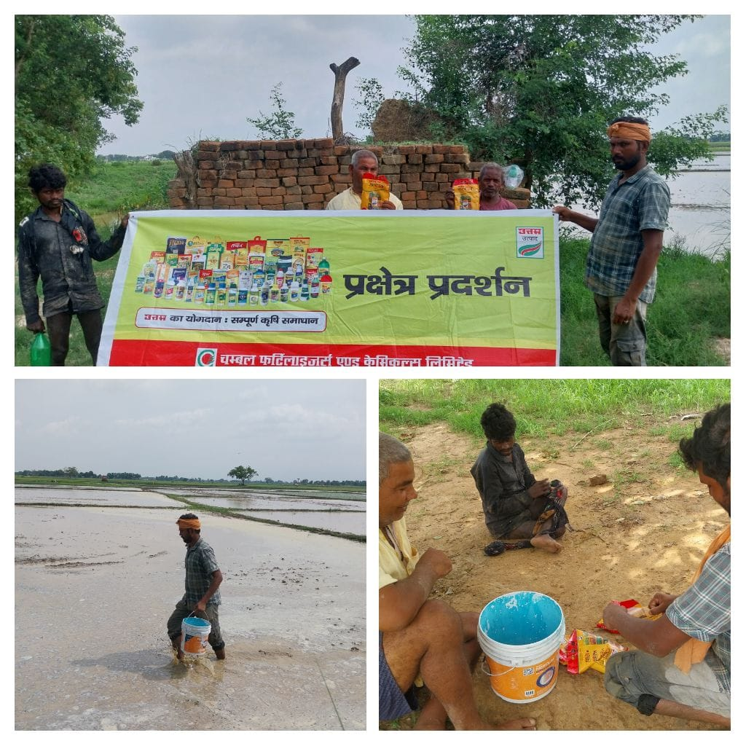

COMBO DEMONSTRATION REPORT – 4
Seed to Harvest
Details Of Farmer
Name of Farmers | ALOK KUMAR PAANDEY
Mobile No. | 7903889173
Village Name | KATARIYA
Block & Tehsil | RAJPUR
District & State | BUXAR

Field And Crop Detail
Total Acreage(acre) | 15 ACRE
Crops Grown | 15 ACRE
Field Location (Easy approach/road side) | ROAD SIDE
Selected - Crop & Variety | PADDY MTU-7029
Trial Plot Area (KATHA) | 32 KATHA (INCULDING T1+ T2+ T3)
Seed Rate (kg/acre) | 8 KG/ACRE
Sowing Date | 04.07.2025

Demo Product Name And Dose& Field day detail
Name of Product | SALTON
Application Dose (ml/acre) | 5.33 KG
Date/Time of Application | 04.07.2025

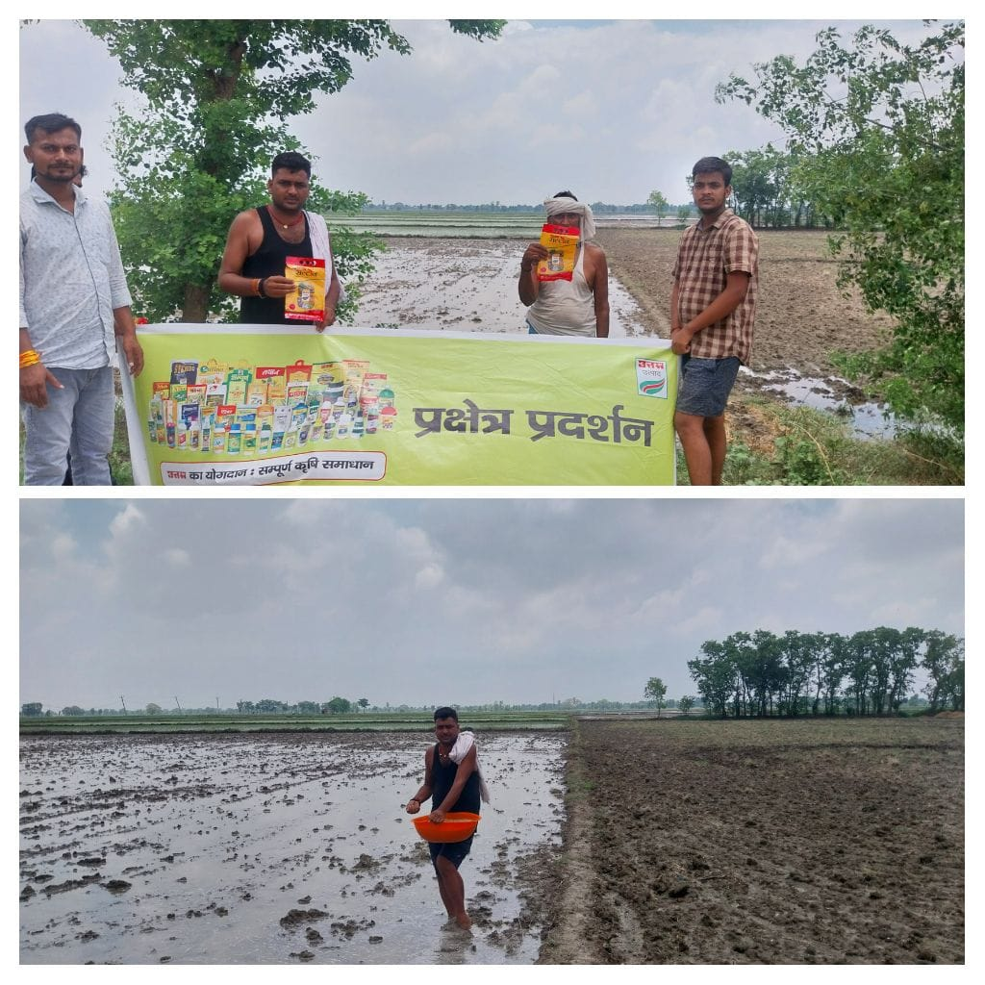

COMBO DEMONSTRATION REPORT – 5
Seed to Harvest
Details Of Farmer
Name of Farmers | MANOJ RAI
Mobile No. | 7670626695
Village Name | KANEHARI
Block & Tehsil | RAJPUR
District & State | BUXAR

Field And Crop Detail
Total Acreage(acre) | 12 ACRE
Crops Grown | 12 ACRE
Field Location (Easy approach/road side) | EASY APPROCH
Selected - Crop & Variety | PADDY MTU-7029
Trial Plot Area (KATHA) | 32 KATHA (INCULDING T1+ T2+ T3)
Seed Rate (kg/acre) | 8 KG/ACRE
Sowing Date | 05.07.2025

Demo Product Name And Dose& Field day detail
Name of Product | SALTON
Application Dose (ml/acre) | 5.33 KG
Date/Time of Application | 05.07.2025

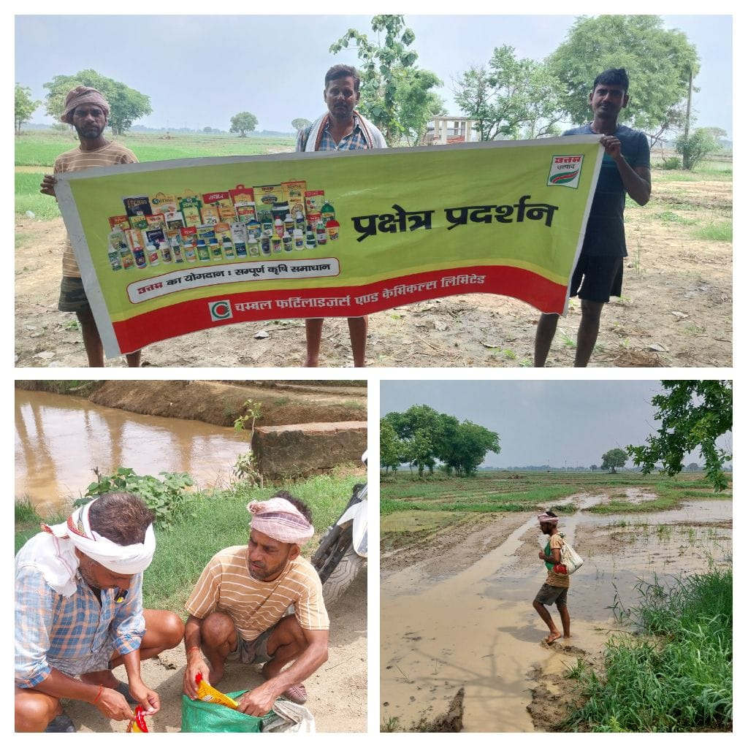
COMBO DEMONSTRATION REPORT – 6
Seed to Harvest
Details Of Farmer
Name of Farmers | RAMMUNIS SINGH
Mobile No. | 9199783566
Village Name | BHOCHAKIYA UNWAS
Block & Tehsil | ITADHI
District & State | BUXAR

Field And Crop Detail
Total Acreage(acre) | 12 ACRE
Crops Grown | 12 ACRE
Field Location (Easy approach/road side) | ROAD SIDE
Selected - Crop & Variety | PADDY MTU-7029
Trial Plot Area (KATHA) | 32 KATHA (INCULDING T1+ T2+ T3)
Seed Rate (kg/acre) | 8 KG/ACRE
Sowing Date | 05.07.2025

Demo Product Name And Dose& Field day detail
Name of Product | SALTON
Application Dose (ml/acre) | 5.33 KG
Date/Time of Application | 05.07.2025

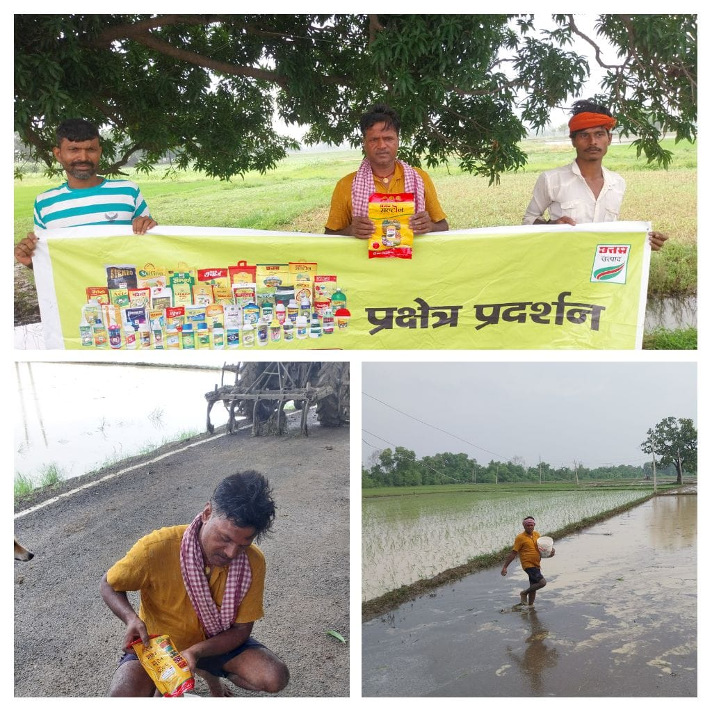

COMBO DEMONSTRATION REPORT – 7
Seed to Harvest
Details Of Farmer
Name of Farmers | SANTOSH KHARWAR
Mobile No. | 7362839592
Village Name | HETHUA
Block & Tehsil | RAJPUR
District & State | BUXAR

Field And Crop Detail
Total Acreage(acre) | 05 ACRE
Crops Grown | 05 ACRE
Field Location (Easy approach/road side) | EASY APPROACH
Selected - Crop & Variety | PADDY MTU-7029
Trial Plot Area (KATHA) | 21 KATHA (INCULDING T1+ T2+ T3)
Seed Rate (kg/acre) | 8 KG/ACRE
Sowing Date | 17.07.2025

Demo Product Name And Dose& Field day detail
Name of Product | SALTON
Application Dose (ml/acre) | 3.5 KG
Date/Time of Application | 17.07.2025

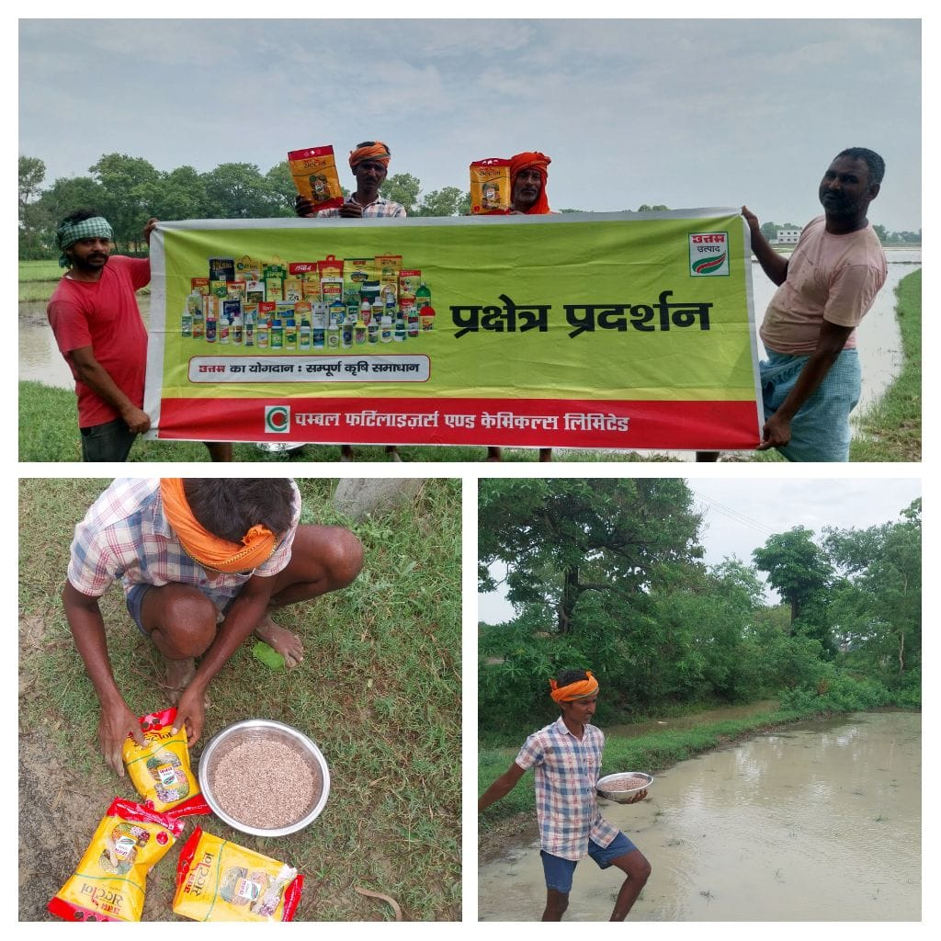

COMBO DEMONSTRATION REPORT – 8
Seed to Harvest
Details Of Farmer
Name of Farmers | RAJKUMAR GAUTAM
Mobile No. | 9546354295
Village Name | UATTARI KALA
Block & Tehsil | RAJPUR
District & State | BUXAR

Field And Crop Detail
Total Acreage(acre) | 10 ACRE
Crops Grown | 10 ACRE
Field Location (Easy approach/road side) | ROAD SIDE
Selected - Crop & Variety | PADDY MTU-7029
Trial Plot Area (KATHA) | 32 KATHA (INCULDING T1+ T2+ T3)
Seed Rate (kg/acre) | 8 KG/ACRE
Sowing Date | 17.07.2025

Demo Product Name And Dose& Field day detail
Name of Product | SALTON
Application Dose (ml/acre) | 5.33 KG
Date/Time of Application | 17.07.2025

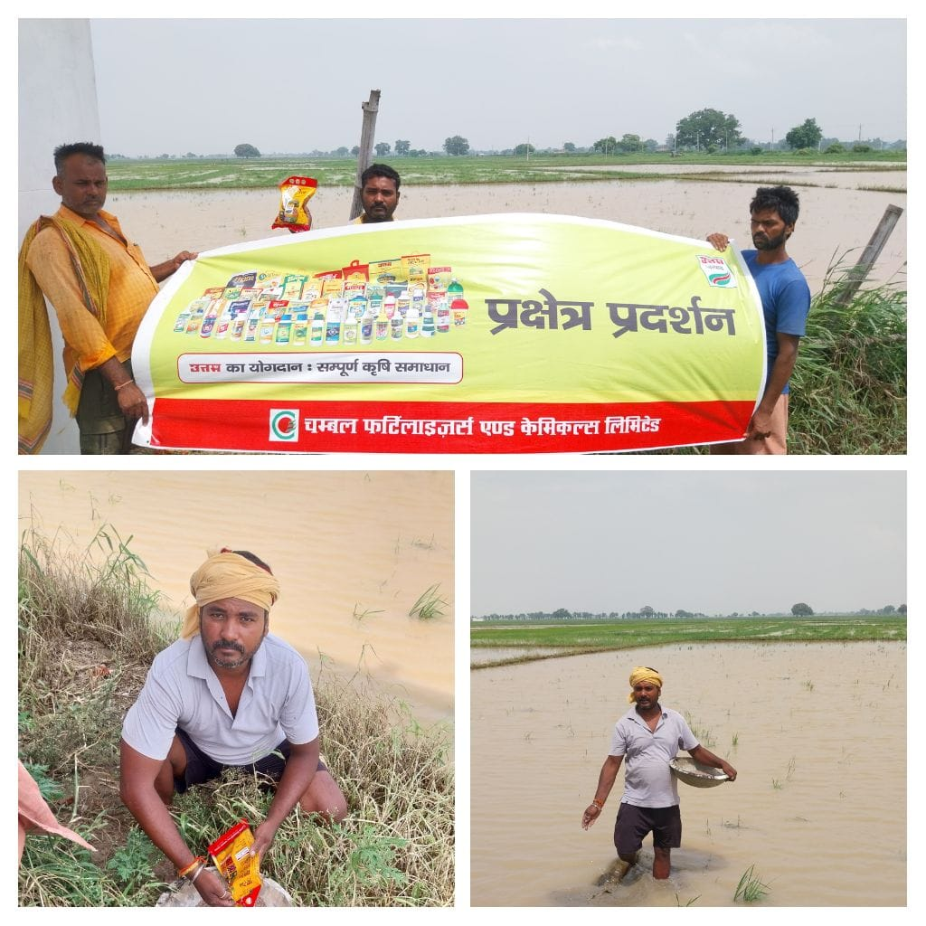

COMBO DEMONSTRATION REPORT – 9
Seed to Harvest
Details Of Farmer
Name of Farmers | JITNARAYAN SINGH
Mobile No. | 9934958547
Village Name | HANKARPUR
Block & Tehsil | RAJPUR
District & State | BUXAR

Field And Crop Detail
Total Acreage(acre) | 07 ACRE
Crops Grown | 07 ACRE
Field Location (Easy approach/road side) | EASY APPROCH
Selected - Crop & Variety | PADDY MTU-7029
Trial Plot Area (KATHA) | 26 KATHA (INCULDING T1+ T2+ T3)
Seed Rate (kg/acre) | 8 KG/ACRE
Sowing Date | 17.07.2025

Demo Product Name And Dose& Field day detail
Name of Product | SALTON
Application Dose (ml/acre) | 4.33 KG/ACRE
Date/Time of Application | 17.07.2025

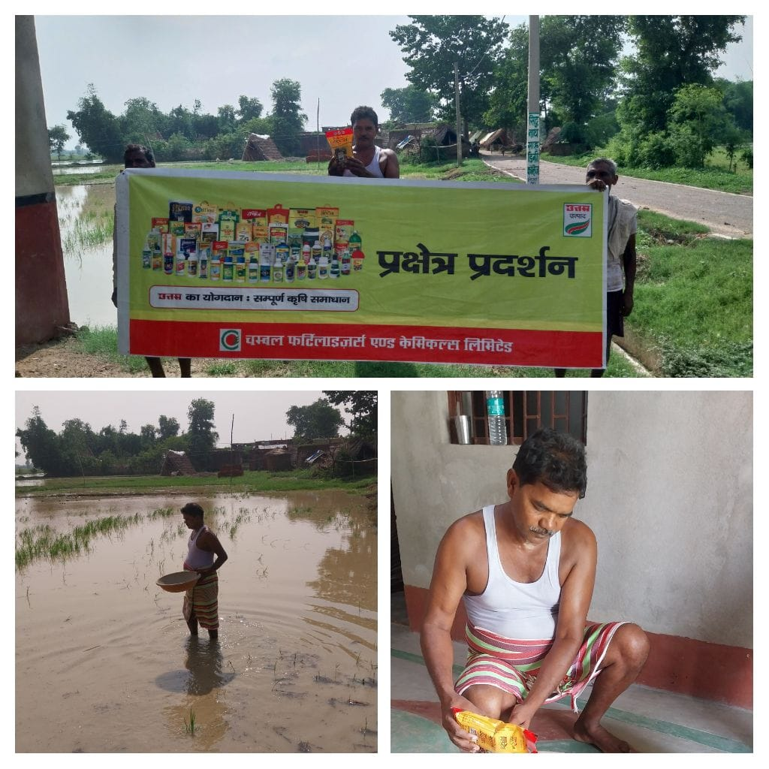
COMBO DEMONSTRATION REPORT – 10
Seed to Harvest
Details Of Farmer
Name of Farmers | SUKHLAL YADAV
Mobile No. | 7319613282
Village Name | KHIRI
Block & Tehsil | RAJPUR
District & State | BUXAR

Field And Crop Detail
Total Acreage(acre) | 8 ACRE
Crops Grown | 8 ACRE
Field Location (Easy approach/road side) | EASY APPROCH
Selected - Crop & Variety | PADDY MTU-7029
Trial Plot Area (KATHA) | 30 KATHA (INCULDING T1+ T2+ T3)
Seed Rate (kg/acre) | 8 KG/ACRE
Sowing Date | 17.07.2025

Demo Product Name And Dose& Field day detail
Name of Product | SALTON
Application Dose (ml/acre) | 5 KG
Date/Time of Application | 17.07.2025
